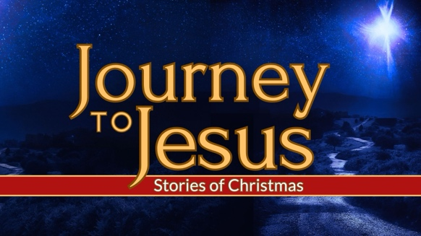
Whyte Ridge Baptist Church – December 8, 2024

Mary & Joseph’s Journey to Jesus

(Luke 1:26-38, Matthew 1:18-25)

“I think there must be something wrong with me…”
“Christmas is coming, but I'm not happy. I don't feel the way I'm supposed to feel. I just don't understand Christmas.”

Our Introduction to Mary (Luke 1:26-38)
What we learn about her from this passage:

Whyte Ridge Baptist Church – December 8, 2024

Mary & Joseph’s Journey to Jesus

(Luke 1:26-38, Matthew 1:18-25)

“I think there must be something wrong with me…”
“Christmas is coming, but I'm not happy. I don't feel the way I'm supposed to feel. I just don't understand Christmas.”

Our Introduction to Mary (Luke 1:26-38)
What we learn about her from this passage:

Our Introduction to Joseph (Matthew 1:18-25)
What we learn about him from this passage:

Mary & Joseph’s journey to the manger

Application:

Our Introduction to Joseph (Matthew 1:18-25)
What we learn about him from this passage:

Mary & Joseph’s journey to the manger

Application:

